LAHORE LEADS UNIVERSITY
AREEBA FAYYAZ
ARITIFICIAL INTELIGENCE
ADP(IT)
MINI PROJECT NO 3
TOPIC:
AI SYSTEM MAP
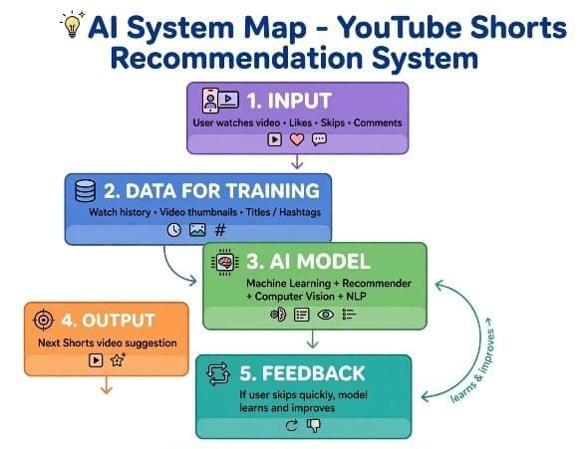
1. INPUT (What user does)
User watches a video, likes it, comments, or skips it quickly. This is the input for AI.
2. DATA FOR TRAINING (What AI needs to learn)
AI needs 3 things to learn: User's watch history, video thumbnails and images, and video titles and hashtags.
3. AI MODEL (How AI works)
AI uses Machine Learning and Recommender System. It also uses Computer Vision to see thumbnails and NLP to understand titles.
4. OUTPUT (What AI gives)
AI suggests the next Shorts video that user will like the most.
5. FEEDBACK (How AI improves)
If user skips the video fast, AI learns that user did not like it and will not show similar videos next time.

